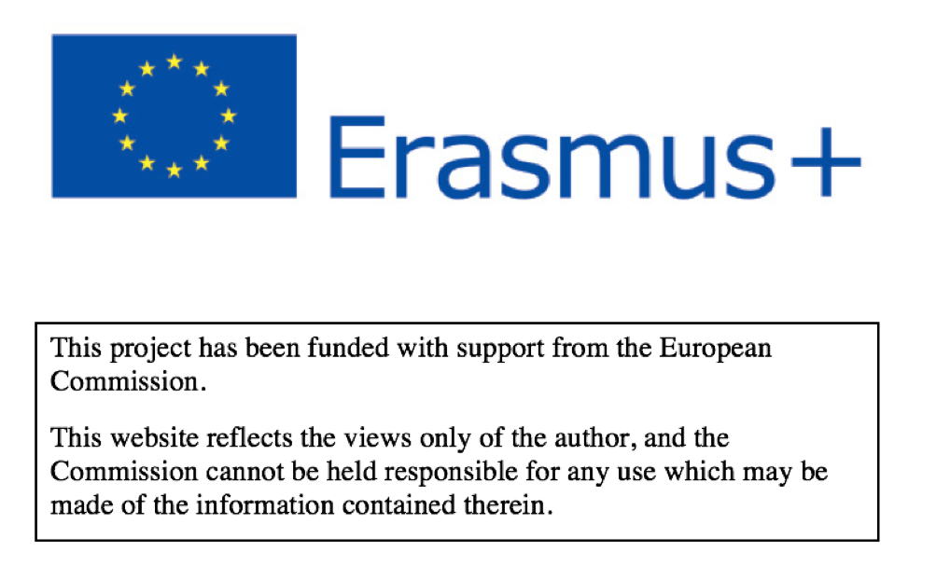

Videogames influence on values – survey
Samples: 35 students aged 12
Media Literacy project
Data from Italy
IIS Mandela, Castelnovo nè Monti
19th February 2018

0.Where are you from?

1.Are you a boy or a girl?

2. Do you play videogames?

3.Who do you normally play with?

4.When do you play videogames?

5.How much time do you spend on playing videogames a week?

6.Do your parents regulate the time you spend on playing videogames?

7.Can you buy and play the videogames you like?

8.Which kind of videogame do you prefer?

9.Which videogame do you prefer?

10.How do you react when your parents tell you to quit playing?

11.How do you feel when someone interrupts you while you are playing?

12.How do you feel when you stop playing?

13.How do you agree with these statements?

14.I think that videogames help me to…

15.How do you feel when you lose a game?

