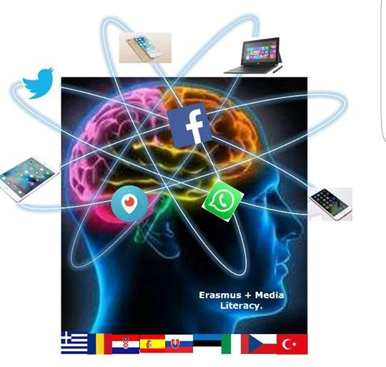

3 Gymnasio Kalamata Understanding and Critical Media Literacy
.
GENDER BASED VIOLENCE part 1
Topic: Annotation / Short summary | Inequality, gender violence, discrimination  To help students understand the what gender based violence is, to be able to identify it and distinguish between the types of gender based violence. This is the first of two lesson plans in a series of lesson plans on gender issues.
Aims: | Cognitive | to help students understand that violence is an option based on socially learned views  to understand how gender stereotypes can lead to abuse and violence against others.  to learn about different types of gender based violence .  to be able to think judgmentally on the topic of violence against women and substantiate their own opinion civilly.  To identify and reject gender stereotypes that relate to violence
 | Linguistic | Vocabulary : characteristics (adjectives) on violence, relationships, gender stereotypes
Age group: | 15 +
Level | Intermediate+
Time | 45 minutes
Materials | PC, interactive board or Video projector, Worksheets, computers, cellphones or tablets for students, large pieces of paper or poster paper, markers, tape (or blue tack)
Procedure | - Introduce topic – What is violence?  - Brainstorming- have a brainstorming session with students- (5-6 minutes), write some of the words on the board  Words that come to mind when I say violence  - Hand out worksheet 1A and ask students to complete it in pairs. Go over it with the students and ask them are these situations are violent and to what degree based on male female violence? (20 minutes) Briefly discuss  - Watch the video up until at 2:44 https://www.youtube.com/watch?v=o9usl_emisA  - what types of violence are there? Ask students to identify the type of violence in the worksheet . Ask them to justify their answer. (10 minutes) Tell students to keep the handout because they will need it during the following lesson.  - Finish the lesson by asking “ Is violence ever necessary? Can it ever be justified?
Closure  (peer activities) | Ask groups to choose one of the following  - create a poster/ collage illustrating different types of violence  - create a poster/ collage to prevent violence  - write a poem or change the lyrics of a song to use in a campaign against violence  - Ask students to create a Word wall (description follows)  Ask students to find articles on the internet about violence. Tell them to focus on one or two articles . Their task is to create a tableau that captures the headline. They should portray the central figures at some point in the past, before the violent episode. Then they should show the central figures at some point in the future. The tableaux should be put in chronological order. They can use words of pictures to create the tableux.
Resources/ Bibliography | http://eige.europa.eu/gender-based-violence/what-is-gender-based-violence  http://hrlibrary.umn.edu/svaw/advocacy/modelsessions/what_is_GBV.PDF  http://mediasmarts.ca/violence/resources-teachers-violence  http://www.gmanetwork.com/news/news/pinoyabroad/250726/emotional-abuse-most-common-type-of-domestic-violence/story/  http://www.health-genderviolence.org/training-programme-for-health-care-providers/facts-on-gbv/defining-gender-based-violence/21  http://www.rcmp-grc.gc.ca/cycp-cpcj/violence/fv-vf/lp-pl/index-eng.htm  http://www.sdcda.org/office/girlsonlytoolkit/toolkit/got-06-violence.pdf  http://www.stepupspeakout.org/coaches-teachers/dating-violence  http://www.taoscav.org/cms-view-page.php?page=different-types-of-violence  http://www.unifem-eseasia.org/Resources/Traffick2.html https://en.wikipedia.org/wiki/Violence  https://www.breakthecycle.org/sites/default/files/dv_101_single_day_lesson_plan.pdf  https://www.justice.gov/ovw/domestic-violence

The European Commission support for the production of this publication does not constitute an endorsement of the contents which reflects the views only of the authors, and the Commission cannot be held responsible for any use which may be made of the information contained therein."

Worksheet 1

Read each incident and check 1= not violent , 2= violent, 3= extremely violent
INCIDENT | 1 | 2 | 3 | Type of violence | GBV
- A girl fights with a boy
- Your mother told you and your brother to tidy the house Your brother was playing and you had a lot of homework so you didn’t finish it all. Your mom punishes only you.
- A friend demands you give her some money because she forgot hers at home
- Your parents scream at each other over household chores.
- You turned a boy down when he asked you out so he has started to spread a rumor about you
- Boys call you names because of the way you dress
- The teacher tells the whole class you failed your test.
- Your boyfriend insists you kiss him in public even though you don’t want to.
- Your older brother helps you with your homework
- Your coach touches your hair after you have asked him not to.
- You’re a boy. Some girls in your class give you the silent treatment because you broke up with their friend.
- An unknown man follows down the street and makes lewd passes at you saying “the way you’re dressed you look like you want it”.
- Your brother takes your new blouse and gives it to his girlfriend as a gift
- Your parents calls you “fat” and say you have to diet.
- Your father threatens to leave you and your family unless you all behave the way he wants you to.
- A psychologically ill woman kills her children.
- Your friend gives you a hug because you feel really down
- Some students tease and harass a classmate who seems feminine, telling him to go play with the girls.
- Your sister breaks your favorite necklace
- Someone threatens to hit you if you don’t let them copy your homework
- A group of male students whistle at a new girl as she enters the school for the first time.
- A man puts his arm around his secretary’s shoulders while they are working together on a project
- A teacher tells a female student she shouldn’t be a doctor because it will take too long and she won’t have time to start a family.
- A husband doesn’t allow his non working wife to handle money of any finances not even grocery shopping.

