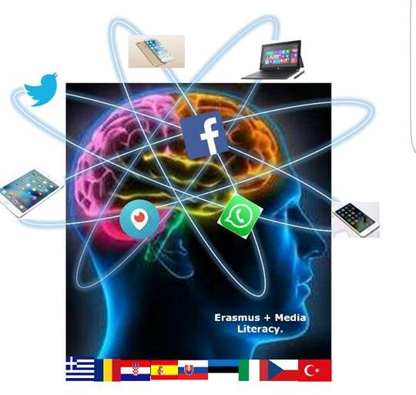

3 Gymnasio Kalamata Understanding and Critical Media Literacy

GENDER BASED VIOLENCE part 2
Topic: Annotation / Short summary | Inequality, gender violence, discrimination  To help students understand the what gender based violence is, to be able to identify it and distinguish between the types of gender based violence. This is the first of two lesson plans in a series of lesson plans on gender issues.
Aims: | Cognitive | - to help students understand that violence is an option based on socially learned views  - to understand how gender stereotypes can lead to abuse and violence against others.  - to learn about different types of gender based violence .  - to be able to think judgmentally on the topic of violence against women and substantiate their own opinion civilly.  - To identify and reject gender stereotypes that relate to violence
 | Linguistic | Vocabulary : characteristics (adjectives) on violence, relationships, gender stereotypes
Age group: | 15 +
Level | Intermediate+
Time | 45 minutes
Materials | PC, interactive board or Video projector, Worksheets, computers, cell phones or tablets for students, large pieces of paper or poster paper, markers, tape (or blue tack)
Procedure | - Introduce topic – Last time we spoke about violence in general and we referred to the different types of violence. Today we will be learning about the group(s) that most violence is directed towards.  - Brainstorming- have a brainstorming session with students- (5 minutes),  - Words that come to mind when I say gender?  - Who is likely to be more violent males or females?  - Now ask students to define ‘gender based violence ’ in their own words. Discuss answers with the group. Hold a discussion about the characteristics of gender based violence. Possible questions to ask :  - Where can this violence occur? Can you give me some examples?  - Why do you think gender based violence happens  - Does gender based violence happen only in countries with emerging market economies or can it happen anywhere?  - Does education play a role? Explain (Who should be educated)  - watch the video https://www.youtube.com/watch?v=3AF9Rjki0DE&t=40s  - Tell students to refer to the previous lesson’s worksheets and mark which of the situations were actually GBV  - Give students two index card for each. Once in green and one in red. Tell students you will read some sentences and you want them to raise the green card if they agree and the red one if they disagree. Read the following statements:  - You insist on what your boyfriend or girlfriend should wear. After all you want them to look good when you are with them  - Being jealous of everything your partner says or does just means you really care.  - It is ok to bad mouth someone who left you for no reason  - If you love someone, it is ok to say “no.”  - It is ok to insist that your girlfriend/ boyfriend do something only because you want them to.  - If someone you are dating “accidently” slaps you during an argument, you should forgive them—no one is perfect.  - If someone loves you, it is ok for them to ask you to do something even if it makes you uncomfortable.  - Sometimes a girlfriend/ boyfriend deserves to be hit, especially if they provoke you.  - If you’re with someone it’s OK not to spend all your free time with them  - Watch https://www.youtube.com/watch?v=LR2EO2KVtu8  - Handout worksheet2
Closure  (peer activities) | - Ask students to note down at least four types of violence that they watched in the trailer, categorize them and explain why they put them in each categoty  - Ask each group to pick one of the instances and act it out deciding on a different course of action  - Ask students to create a poster to help spread awareness for GB relationship violence  - Write a short play in which a friend helps the person experiencing violence to escape
Resources/ Bibliography | http://eige.europa.eu/gender-based-violence/what-is-gender-based-violence  http://hrlibrary.umn.edu/svaw/advocacy/modelsessions/what_is_GBV.PDF  http://mediasmarts.ca/violence/resources-teachers-violence  http://www.gmanetwork.com/news/news/pinoyabroad/250726/emotional-abuse-most-common-type-of-domestic-violence/story/  http://www.health-genderviolence.org/training-programme-for-health-care-providers/facts-on-gbv/defining-gender-based-violence/21  http://www.rcmp-grc.gc.ca/cycp-cpcj/violence/fv-vf/lp-pl/index-eng.htm  http://www.sdcda.org/office/girlsonlytoolkit/toolkit/got-06-violence.pdf  http://www.taoscav.org/cms-view-page.php?page=different-types-of-violence  https://www.breakthecycle.org/sites/default/files/dv_101_single_day_lesson_plan.pdf

The European Commission support for the production of this publication does not constitute an endorsement of the contents which reflects the views only of the authors, and the Commission cannot be held responsible for any use which may be made of the information contained therein."
Look at the the pictures in the following chart. Do you see examples of gender based violence, if yes, which type of violence is it?
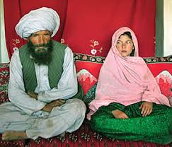 | 