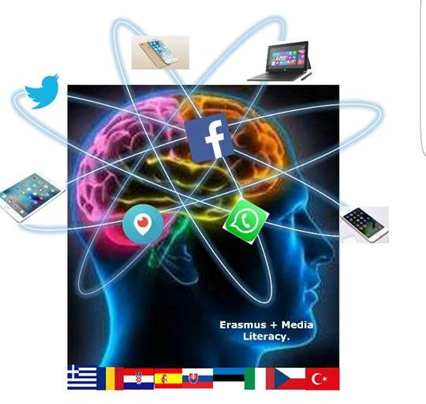

3 Gymnasio Kalamata Understanding and Critical Media Literacy

GENDER STEREOPTYPING
Topic: Annotation / Short summary | Inequality, gender discrimination, stereotypes, assumptions, identity  To help students examine their own assumptions about what it means to be a man, and what it means to be a woman. So that they may understand that although gender roles may be thought to sometimes be inherent they could limit women’s and men’s life choices and opportunities.
Aims: | Cognitive | - To define gender stereotypes and their impact on people’s identities  - to help students understand their own gender assumptions and stereotypes  - to understand how gender stereotypes can lead to inequality  - To identify and reject gender stereotypes that limit one’s ability to make valuable decisions  - name at least one way in which gender stereotypes may limit
 | Linguistic | Vocabulary : characteristics (adjectives)relating to gender stereotypes
Age group: | 15 +
Level | Intermediate+
Time | 90 minutes – depending on the participants an extra 30 minutes may be needed
Materials | PC, interactive board or Video projector, Worksheets, computers, cell phones or tablets for students, large pieces of paper or poster paper, markers, tape (or blue tack)
Procedure | Facilitator’s note: familiarize yourself with the definitions for  Sex: the biological anatomy we are born with  gender: social ideas about what it means to be masculine or feminine  stereotype: a popular belief about a group of people, based on assumptions that may often be inaccurate and extreme.  - Begin by placing two boxes in the front of the room. One box should be labeled “Be a man”, the other “Ladylike”. At first, the labels on the boxes should not face the students. Tell students “today we will start with an activity.” Go around and hand each student a picture flashcard and a word flashcard-. The flash cards do not have to correspond to a male and female for each student although it is preferable.  - Ask students to look at their cards. Turn the boxes so they can see the labels Then ask them to come up to the front and place each of their cards in one of the boxes.  - Once all the cards have been placed in the box divide the students into mixed groups. Randomly pull a card out of one box and ask each group to say if they can explain why the cards should be thought of as masculine or feminine. Do this with 5-6 cards or more if time allows. Ask students if they have ever experienced a situation where they were called, expected to act or not act like the word or picture on the card. ( Eg. “ calling a boy a delicate or a girl a rowdy / having been told not to play with dolls/ football (boy/girl accordingly);etc.”  Tell the students these attributes are called stereotypes. “What is a stereotype? Define and write the definition on the board. Ask for a definition of gender. Make sure students understand the difference between gender and sex  Who are stereotypes learnt from (who teaches them to us?) Elicit answers like parents, teachers, Media? (If the students respond "TV" or "movies," ask for specific examples to list.)  - Handout worksheet one (Students can do it individually or in their groups)  Give them 5 minutes. Go over it together.  - Discuss – Who has society more stereotypes for males or females? why?  Can a stereotype be helpful?  - Watch the video https://www.youtube.com/channel/UCE5yTn9ljzSnC_oMp9Jnckg  - Which stereotypes are illustrated in the video? Discuss. (no more than 10 min) Students should point out as many as possible- acting sexy to get a guy – looking pretty to get a man to pay for them, dressing provocatively, cosmetic surgery, being passive, etc. End the discussion with the question “Does the video show the inequity we discussed before?” Is it realistic?  Evaluating Stereotypes:  Break the groups up and handout worksheet 2 to each student. Once students are done tell them that the first two questions are designed to distract and do not really have to do with gender assumptions. The rest of the questions should be ‘don’t know’ because no genders or sexes are given in the scenario. If they have other answers it shows that they too make gender assumptions.  If there is time left end with the riddle-“ a father and son are in a horrible car crash that kills the dad. The son is rushed to the hospital; just as he’s about to go under the knife, the surgeon says, “I can’t operate - that boy is my son!” Explain.  Most students should see that the surgeon is the boy’s mother. Give points to those who say boy’s gay second father- shows non-conforming social attitudes
Closure  (peer activities) | - Ask students to create a poster to help spread awareness for gender stereotypes  - Plan a silent debate. (from https://oliver-furnival.squarespace.com/videos-1/)  - Produce a wall chart containing 4 elements: write the statement of the problem at the top of the chart, 4 or more possible ideas for handling the problem.  - One phrase to sum it up- students write a phrase (or small sentence on the topic of the lesson or what they got from it)  - Graffiti board- Tape a large piece of paper to a wall- students come up to the paper in groups of four or more and write or draw the first thing that comes to mind when they think of this topic.  - Create a story from pictures—Students find pictures in magazines, newspapers or the internet and create a short storyboard on the topic.  - Create a Gallery Walk- Attach a long rectangular piece of paper to a wall, ask each group to write and draw what they learned. Have one person from each group attach the groups completed works to the wall. When all groups have finished each group passes along the wall “Gallery”. They  - others students affix post its to the posters to extend on the ideas, add questions, or offer praise.  - Write a song on gender stereotypes.  - Write a reversed version of a fairy tale
Resources/ Bibliography | - Hayward, J. (2002) Work Matters: A Key Stage 4 Teacher Resource Exploring the Employment Strand of Citizenship, Institute for Citizenship, p.42, 43 & 47.  - http://endvawnow.org/uploads/browser/files/voices_against_violence_middle_en.pdf  - https://www.healthguidance.org/entry/15910/1/List-of-Gender-Stereotypes.html  - https://nustem.uk/wp/wp-content/uploads/2016/06/Unconscious-Bias-in-the-Primary-Classroom.pdf  - https://education.gov.scot/improvement/learning-resources/Improving%20gender%20balance%203-18  - http://52quotes.blogspot.com/2016/03/  - https://oliver-furnival.squarespace.com/videos-1/  - https://www.tandfonline.com/doi/abs/10.1080/00049530412331283363  - www.offtherecord-banes.co.uk/our-services/domestic-violence-abuse/  - www.open.edu/openlearncreate/mod/resource/view.php?id=133420
The European Commission support for the production of this publication does not constitute an endorsement of the contents which reflects the views only of the authors, and the Commission cannot be held responsible for any use which may be made of the information contained therein."
Worksheet 1
STATEMENT | Agree | Dis-agree
- In the 2015 global census 49.55% of the global population were women. Only 21.9% held positions in national governments
- There are more women than men teachers, especially in primary schools. This gives girls positive role models.
- Parents buy different toys for their sons and daughters
- Girls study more than boys so they usually do better at exams.
- Boys tend to be better at math and sciences than girls.
- Girls’ priorities in the job market have changed in the last 25 years.
- The world’s most powerful companies are mostly run by men. There are only 26 female CEOs in this year’s Fortune 500 companies, and only 54 in the top 1000.
- Women are paid less than men for the same job in countries all over the world.
- Boys are less likely to work consistently harder than girls and are more easily distracted
- Low self-esteem in boys may be linked to images of less aggressive men found in media advertising, sitcoms and soaps, etc. This low self-esteem may also be linked to the decline in male traditional male jobs, leaving boys uncertain about their futures and lacking motivation.
- Government initiatives are trying to encourage more girls to do science & technology and have made school more “girl friendly”. This has caused a decline in boys’ achievements

Worksheet 2

Read the following scenario and tick the box you agree with

A builder, leaning out of the van, shouts “nice legs” to a nurse passing by. The same nurse arrives at work, and casually mentions this to a senior doctor. The doctor said,” I’d never say that”. The doctor has two grown up children who are 22 and 30. They get on very well. One is a Sergeant in the army; the other is training to be a beauty therapist. The doctor divorced last year and is currently dating someone else.

Answer the following based on the information above. Tick appropriate box | True | False | Don’t know
- The builder was driving a van

- The van was travelling quicker than the nurse
- There was at least one man in the van

- Not every man mentioned would shout “nice legs”
- The doctor is no longer living with his wife
- The doctor has a new girlfriend

- The doctor’s son is in the army

- The youngest child is training to be a beauty therapist
- At some point a man spoke to a woman

- At least two of the people mentioned are men
- A woman was shouted at

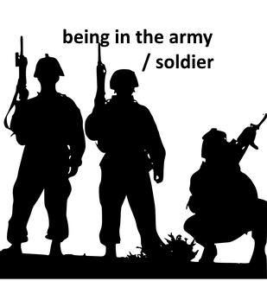 | 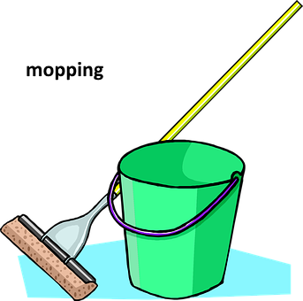 | 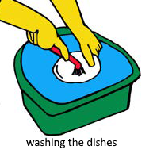
 | 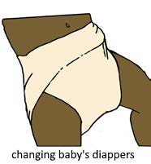
 | 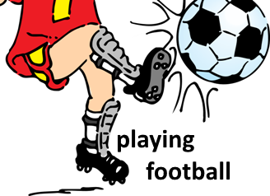 | 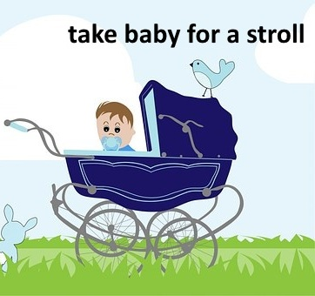
 | 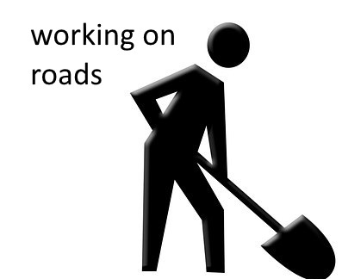

For examples of words and pictures please check our web page at
https://understandingandcriticalmedialiteracy.weebly.com/greece1.html

