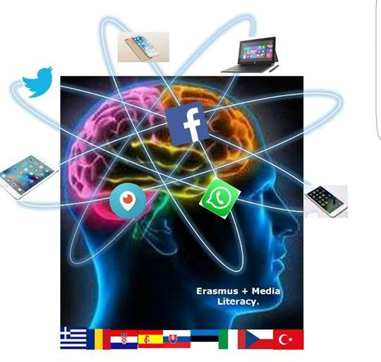

3 Gymnasio Kalamata Understanding and Critical Media Literacy

NAME USING THE INTERNET SAFELY &WISELY
Topic: Annotation / Short summary | Online safety, identity theft, private(privacy) , personal data, freedom of expression, censorship.  Strategies to help understand how to use the internet safely and wisely In this lesson, students explore the importance of the terms: Discover how students can protect their personal dat a and become familiar with maintaining a positive digital imprint
Aims: | Cognitive | To help students to understand the importance of issues like identity and digital identity and the consequences that may arise from careless posting on the web  To comprehend the meaning of privacy and digital footprints and to learn to protect their own privacy and their digital reputation  To understand the concept of globalization and the interactions between individuals and the wider community;  To cultivate the values ​​of moral behavior and respect for others.  Encourage students to work collaboratively.  Encourage students to study resources, analyze material and to present conclusions in a creative way.  To develop pupils' leadership skills (ability to co-operative actions).
 | Linguistic | Vocabulary related to the web
Age group: | 14 +
Level | Intermediate+
Time | 90-minutes ( 2 school periods- more time may be needed depending on student level/ age)
Materials | Video projector, internet connection board, markers,
Procedure | a ) Divide students into groups of four- five persons.  Introduce the topic. Tell the students “ Today we are going to be focusing on correct internet usage. All of you use the internet daily so I would like you to discuss these words in your groups and write a definition for each of them: privacy , personal data, freedom of expression, censorship, online safety, identity theft , cyberbullying, fake news and where possible create a list of words related to the these terms (eg personal data = address, phone number, etc)  b) Discuss the definition for 4-5 minutes.  c) Ask students what can happen if you post too many of these things on the net. Give them 4-5 minutes to discuss in their groups. Tell them to jot down the answers.  d) hand out worksheet 1 - Give students time to complete it. Once they have done so have a group discussion ( 7-10 min)  e) watch the video https://www.youtube.com/watch?v=ceSUuKMr4xo .  While watching try to identify what each “customer” represents.  f) Discussion, reflexion In their groups ask the students to compare answers and decide what each customer represents. (3-4 min.)  g) Ask one person from each group to present results ( 4-5 min) Discuss with whole group)
Closure  (peer activities) | Each group should pick one customer from the video and carry our one of the following to illustrate the customer demand. Give solutions or suggestions: Allow at least 20 minutes  Create and aswergarden here or a word cloud here  Create an infograph here ( You need to create an account- free)  Create a poster with slogans  Create a brochure  Write and perform a 3-5 minute skit  Write a guide for parents to help them keep their children safe online  One person from each group presents the work to the whole group (5 minutes for each group)
Follow up (homework) | None
Resources/ Bibliography | https://www.childnet.com/  http://www.webwewant.eu/  https://www.betterinternetforkids.eu

The European Commission support for the production of this publication does not constitute an endorsement of the contents which reflects the views only of the authors, and the Commission cannot be held responsible for any use which may be made of the information contained therein."
Worksheet 1
Taking a photo with your
family while on holiday (landmark showing) and posting it on Instagram
Taking a photo of yourself and posting it on Facebook

Write a blog to
promote a school event
Allow others to take rude pictures of you.

Posting pictures of yourself without any clothes on

Sexting an image of your boy/girlfriend to your best friend

Taking your clothes off in front of a webcam because someone online has asked you to

Sending a sexual image of yourself using snapchat

Posting a photo of yourself having a good time at a party

Letting friends of friends see your online profile
Sending a sexual image of yourself to someone you have met online
Printing out a sexual image that your friend sent to you to show an adult

Undressing in front of the camera while talking to a friend (video chat)

Read the bubbles and
- Circle the things you would do
- Tick the things you might do
- Mark a cross over the things you would never do
Then discuss with your class why or why not tou would act this way. Be prepared to support your answers

