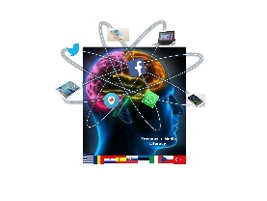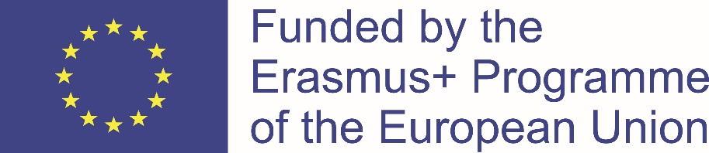
Ka2 „understanding and critical media literacy“

MINUTES OF THE TRANSNATIONAL MEETING IN THE CZECH REPUBLIC
26th MAY – 2ND JUNE 2019
PRAGUE, CZECH REPUBLIC

We, as contact persons/organization representatives, report that we have agreed on the following subjects that are carried out, decided or planned jointly about the partnership project.
- The partners of the KA2 strategic partnership “Understanding and Critical Media Literacy” from Croatia, the Czech Republic, Estonia, Greece, Italy, Romania, Slovakia, Spain and Turkey, have joined the transnational meeting in Prague, Czech Republic, on 26th May – 2nd June 2019 that was organized by the Czech partner. The number of the participants according to the country are shown in the following table:

COUNTRY | Nr. OF PARTICIPANTS/ STUDENTS
CROATIA | 3 + 3
CZECH REPUBLIC | 2 + 3
ESTONIA | 2 + 5
GREECE | 2 + 2
ITALY | 2 + 5
ROMANIA | 2 + 2
SLOVAKIA | 3 + 3
SPAIN | 3 + 6
TURKEY | 2 + 4
TOTAL | 54

- The participants were welcomed by the Czech representative on Sunday 26 th May in the hotel and students were picked by host families up.
- On Monday 27 th May, students staying in host families attended English lessons from 8´45 AM till 10´25 AM at “Soukromé osmileté gymnasium Dino High school, s. r. o., Bellova 352, Prague”. Other participants arrived to the Dino high school at 10 AM and they were welcomed by Monika Kocurková who organized the meeting. Then the participants were welcomed by the owner of the school, school headmaster and deputy headmistress. The instructions about the activities of the meeting were presented. After lunch there was a walk to the Hostivař reservoir arranged and after that, the participants were taken back to the hotel and students were picked by the host families up.
- On Tuesday 28 th May the participants attended a lecture at Seznam.cz and visited a national radio stations and television. Then a tour around Prague was organized with a tour guide.
- On Wednesday 29 th May the participants visited Karlštejn castle.
- On Thursday 30 th May the participants visited radio station. Sightseeing trip around Jewish town was arranged with a tour guide and then boat trip around Vltava was booked.
- On Friday 31 st May, students attended English lesson at “Soukromé osmileté gymnasium Dino High school, s. r. o., Bellova 352, Prague”. After lunch the participants attended 1 st day of the conference in DOX, Centre for Contemporary Art, where they talked about the experiences everybody has had during this three-year project. Students and teachers were sharing their thoughts with other participants.
- On Saturday 1 st June the participants attended a conference open to the public from 9 AM till 10 PM were participants presented their lesson plans. Many people took and interest to visit the conference with around 125 visitors. The final book was presented.

LESSON PLANS
- Each lesson plan has three logos: Erasmus+ logo, project logo, school/organization logo)
- Duration of the lesson was about 30- 45 minutes

FINAL BOOK
- Each school/organization prepared maximum of 30 pages for the book which consisted of: description of the school/organization, lesson plans, feedback from the students participating in the project
- In the final book, lesson plans were categorized according to the topics that they depicted
- Digital version of the book consists of more material – photos, videos, any other products done within the project. Digital version is on an USB memory stick.
- Student´s feedback – 2 or 3 minutes video where students are talking about their experience

ETWINNING
- Each partner was obliged to upload all the project outcomes in the etwinning platform by the mobility in Prague

MOBILITY IN PRAGUE + MULTIPLIER EVENT
- Arrival day was 26th May, departure day was 2nd June 2019
Description of the multiplier event from the application form was the following:
The audience were teachers from secondary schools, staff of the school clubs, students and other people who took interest in our conference, considering people who work for Google and Linkedin.com. The workshops were prepared by project partners. The aim was the dissemination of the example of good practice. The Czech partner was responsible for the event.
Extra expenses were required for translation, equipment (e.g. hiring interpreting booth), audio and visual equipment, renting the premises, issuing the conference materials (minutes, agenda, presentations, leaflets, etc.), expenses for participants from the partner’s countries, conference catering for participants, refreshments.
- Monika Kocurková took the role as a moderator at both conferences – multiplier event
- Each country had a table at the conference where they presented themselves (information about the country, city, their school, culture, traditions, etc.). Each partner prepared something interesting and interactive. The participants brought prospects about their schools, business cards, provided information about their previous projects, souvenirs or products from their countries
- During the multiplier event, the students presented one whole lesson plan, presentation of each took about 30- 45 minutes.
- One student from each country talked about the work on the project, activities that they were doing and how, their impression and final evaluation and feedback
- Pictures of the meetings, slide shows were shown during the conference as well as videos were played.

CONTACT PERSONS/ ORGANIZATION REPRESENTATIVES
NAME AND SURNAME | COUNTRY
Dragana Matković | Croatia
Tomáš Nedvěd | Czech Republic
Maris Nõmmik-Kärtner | Estonia
Maria Mitarea | Greece
Sara Ferrari | Italy
Marian Dragomir | Romania
Lucia Mikulová | Slovakia
Jordi Planellas | Spain
Olcay Belli | Turkey

