1. The news about the meeting in Croatia

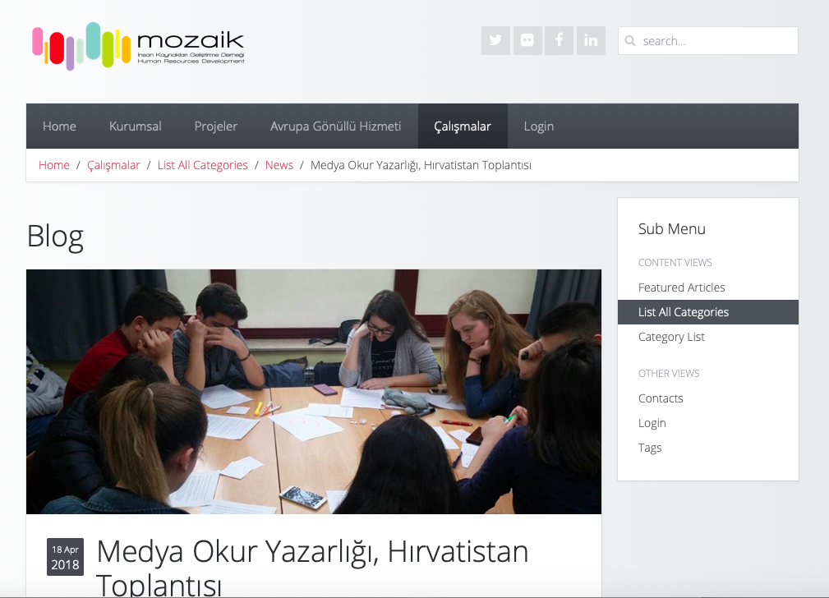

2.. The news for the meeting in Greece

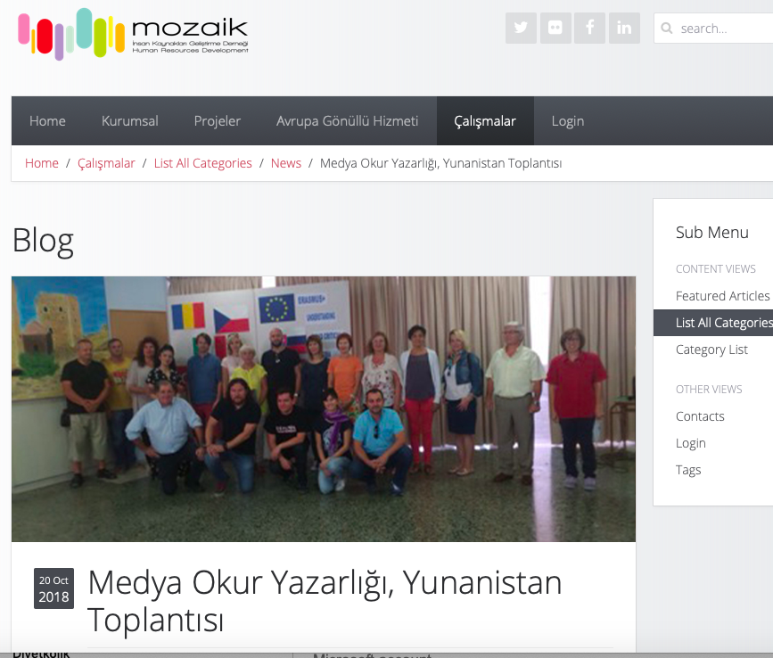

3.. The news for the meeting in Romania

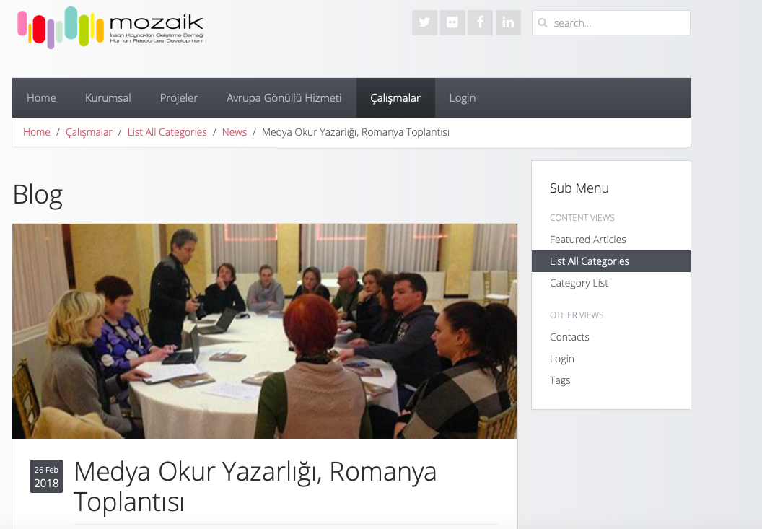

4.The news about the meeting in Spain

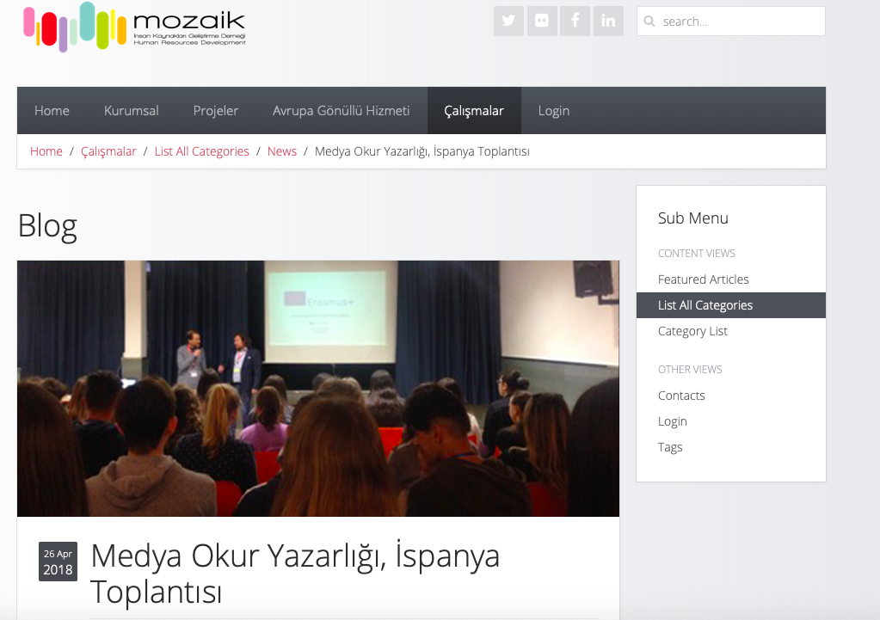

5. The news for the meeting Italy

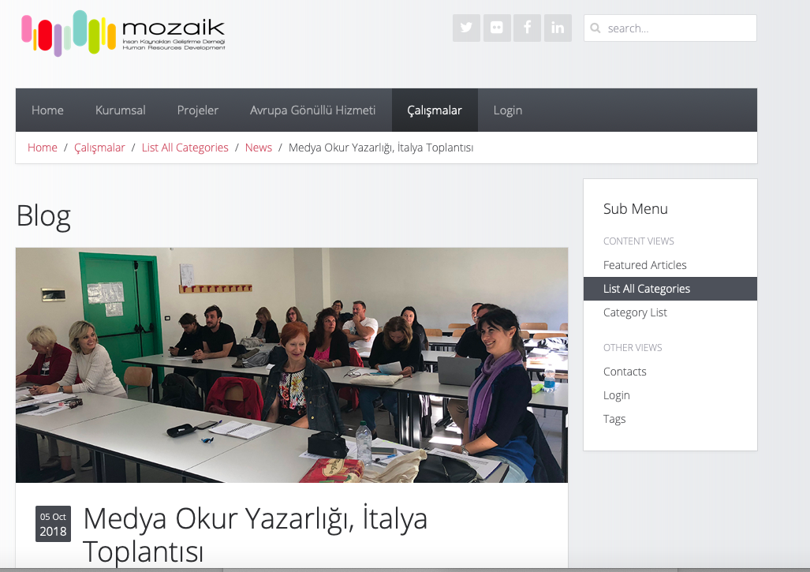

6. A banner about ‘’Understanding and Critical Media Literacy’’ project was created and published by Mozaik Human Resources Development and was hanged in various local events in order to increase the visibility of the project.

